McCann Chiropractic New Patient Intake Form

Patient Data Date ____

Title: (Check one) ⁫ Mr. ⁫ Mrs. ⁫Ms. ⁫ Miss ⁫ Dr. ⁫ Other _______

First Name ___________________ Middle Initial ____ Last Name __________________________

Address Line 1 _____________________________________________________________________

Address Line 2 _____________________________________________________________________

City _______________________________ State ___________________ Zip Code ______________

Home Phone (_____) ________-___________ Work Phone (_____) _________-____________

Cell Phone (_____) ________-___________ Email ___________________________________

Date of Birth ______/______/_______ Sex: ⁫ Male ⁫ Female

Social Security Number: ______-_____-______ Marital Status: ⁫ Single ⁫ Married ⁫ Other

Employment Status: ⁫ Employed ⁫ Unemployed ⁫ FT Student ⁫ PT Student ⁫ Other_____

Employer Data_____________________________________________________________________

Name ____________________________________________________________________________

Your Occupation _________________________ Your Job Description _____________________

Address __________________________________________________________________________

City ________________________________ State _________________ Zip Code ______________

Spouse Data ____

First Name ___________________ Middle Initial _____ Last Name _________________________

Home Phone (_____) _______-__________ Work Phone (_____) _________-____________

Emergency Contact_________________________________________________________________

Contact Name ____________________________ Relationship to Patient ___________________

Contact Home Phone (_____) _______-________ Cell Phone (_____) ________-______________

Doctor’s Signature ________________________________________

Patient Name________________________________________________Date___________________

How did you hear about our office? ___________________________________________________

Medical Conditions: (Check all that apply to you)
⁫ Arthritis ⁫ Cancer ⁫ Diabetes ⁫ Heart Disease
⁫ Hypertension ⁫ Psychiatric Illness ⁫ Skin Disorder ⁫ Stroke
⁫ Other ______________

Surgeries: (Check all that apply to you)
⁫ Appendectomy ⁫ Cardiovascular procedure ⁫Cervical spine ⁫ Hysterectomy
⁫ Joint Replacement ⁫ Prostate ⁫ Lumbar spine ⁫ Gall Bladder
⁫ Brain ⁫ Shoulder ⁫ Thoracic spine ⁫ Knee
⁫ Carpal Tunnel ⁫ Gastro-intestinal ⁫ Uro-genital ⁫ Hernia
⁫ Other ______________

Allergies: (Check all that apply to you)
⁫ Eggs ⁫ Fish and Shellfish ⁫ Milk or Lactose ⁫ Peanuts
⁫ Soy ⁫ Sulfites ⁫ Wheat/Glutens ⁫ Other _________

Social History: (Check all that apply to you)
Caffeine use: ⁫ occasional ⁫ often ⁫ never
Drink Alcohol: ⁫ occasional ⁫ often ⁫ never
Exercise: ⁫ occasional ⁫ often ⁫ never
Chew Tobacco: ⁫ occasional ⁫ often ⁫ never
Cigarettes: ⁫<1 pack/day ⁫ >1 pack/day ⁫ never
Wear Seat Belts: ⁫ occasional ⁫ always ⁫ never
Other ________________

Family History: (Check all that apply)
Arthritis: ⁫ Parent ⁫ Sibling
Cancer: ⁫ Parent ⁫ Sibling
Diabetes: ⁫ Parent ⁫ Sibling
Heart Disease ⁫ Parent ⁫ Sibling
Hypertension ⁫ Parent ⁫ Sibling
Stroke ⁫ Parent ⁫ Sibling
Thyroid ⁫ Parent ⁫ Sibling
Other _________________

Occupational Activities: (Check one that best describes your job description)
⁫ Administration ⁫ Business Owner ⁫ Clerical/Secretary ⁫ Computer User
⁫ Heavy Equipment operator ⁫ Daycare/Childcare ⁫ Construction ⁫ Health Care
⁫ Food Service Industry ⁫ Medium Manual Labor ⁫ Manufacturing ⁫ Home Services
⁫ Heavy Manual Labor ⁫ Light Manual Labor ⁫ Executive/Legal ⁫ Housekeeper
⁫ Other ________________

Doctor’s Signature ________________________________________
Patient Name__________________________________________________Date_________________

Review of Systems – (Check box if you have had trouble with any of the following, circle NO if none)

Cardiovascular |  |  | No | Respiratory |  |  | No | Allergic/Immunologic |  |  | No
 | Past | Present |  |  | Past | Present |  |  | Past | Present
Poor Circulation |  |  |  | Asthma |  |  |  | Hives
Hypertension |  |  |  | Tuberculosis |  |  |  | Immune Disorder
Aortic Aneurism |  |  |  | Short Breath |  |  |  | HIV/AIDS
Heart Disease |  |  |  | Emphysema |  |  |  | Allergy Shots
Heart Attack |  |  |  | Cold/Flu |  |  |  | Cortisone Use
Chest Pain |  |  |  | Cough
High Cholesterol |  |  |  | Wheezing
Pace Maker |  |  |  |  |  |  |  | Ear, Nose and Throat |  |  | No
Jaw Pain |  |  |  | Eyes |  |  | No |  | Past | Present
Irregular Heartbeat |  |  |  |  | Past | Present |  | Difficulty Swallowing
Swelling of legs |  |  |  | Glaucoma |  |  |  | Dizziness
 |  |  |  | Double Vision |  |  |  | Hearing Loss
Genitourinary |  |  | No | Blurred Vision |  |  |  | Sore Throat
 | Past | Present |  |  |  |  |  | Nosebleeds
Kidney Disease |  |  |  | Psychiatric |  |  | No | Bleeding Gums
Burning Urination |  |  |  |  | Past | Present |  | Sinus Infections
Frequent Urination |  |  |  | Depression
Blood in Urine |  |  |  | Anxiety |  |  |  | Gastrointestinal |  |  | No
Kidney Stones |  |  |  | Stress |  |  |  |  | Past | Present
Lower Side Pain |  |  |  |  |  |  |  | Gall Bladder Problems
 |  |  |  | Endocrine |  |  | No | Bowel Problems
Neurologic |  |  | No |  | Past | Present |  | Constipation
 | Past | Present |  | Thyroid |  |  |  | Liver Problems
Stroke |  |  |  | Diabetes |  |  |  | Ulcers
Seizures |  |  |  | Hair Loss |  |  |  | Diarrhea
Head Injury |  |  |  | Menopausal |  |  |  | Nausea/Vomiting
Brain Aneurysm |  |  |  | Menstrual |  |  |  | Bloody Stools
Numbness |  |  |  |  |  |  |  | Poor Appetite
Severe Headaches |  |  |  | Hematologic |  |  | No
Pinched Nerves |  |  |  |  | Past | Present |  | Musculoskeletal |  |  | No
Parkinson’s |  |  |  | Hepatitis |  |  |  |  | Past | Present
Carpal Tunnel |  |  |  | Blood Clots |  |  |  | Gout
Vertigo |  |  |  | Cancer |  |  |  | Arthritis
 |  |  |  | Bruising |  |  |  | Joint Stiffness
Constitutional |  |  | No | Bleeding |  |  |  | Muscle Weakness
 | Past | Present |  | Fever, Chills |  |  |  | Osteoporosis
 |  |  |  | Sweating |  |  |  | Broken Bones
Weight Loss/Gain |  |  |  |  |  |  |  | Joints Replaced
Low Energy Level
Difficulty Sleeping

Please list all current medications being taken ________________________________________________
__________________________________________________________________________________________________________________________________________________________________________

Doctor’s Signature ________________________________________
Patient Name____________________________________________Date_________________________

Are you pregnant? Yes_____ No ______N/A______

By Using the key below, indicate on the body diagram where you are experiencing the following symptoms:
N=Numbness B=Burning S=Stabbing T=Tingling A=Dull Ache
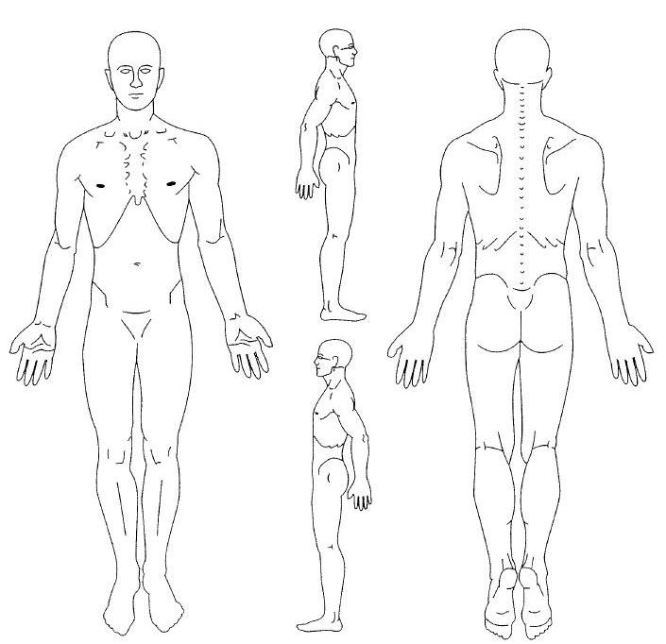
Describe your symptoms in order of severity, with worse symptom being #1: ___________________
__________________________________________________________________________________________________________________________________________________________________________
_____________________________________________________________________________________

When did your symptoms begin? Month_____________ Day___________Year ______________

Are your symptoms a result of: ⁫ Motor Vehicle Accident ⁫Work related Accident ⁫ Other_____

How did your symptoms begin? _________________________________________________________
_____________________________________________________________________________________

How often do you experience your symptoms?
⁫ Constantly ⁫ Frequently ⁫ Occasionally ⁫ Intermittently
(76-100% of the day) (51-75% of the day) (26-50% of the day) (0-25% of the day)

What describes the nature of your symptoms?
⁫ Sharp ⁫ Dull ache ⁫ Numb ⁫ Shooting
⁫ Burning ⁫ Tingling ⁫ Stabbing ⁫ Other ______

Doctor’s Signature ________________________________________

Patient Name Date

How are your symptoms changing?
⁫ Getting better ⁫ Not changing ⁫ Getting worse

Employment, ADL, and Recreation Information

Outcomes Assessment Tool Used ___________________________________________ Score _____________________

Description of Work: _______________________________________________________________________________

Condition’s Effect On Job Performance:  No Effect  Mild (painful can do) Mod (painful limited ability)
 Mod/Sev (limited duty)  Sev (no limited duty) Sev (can’t do limited duty)

Daily Activities: Effects of Current Condition on Performance
Bending: No Effect Mild Painful (Can do) Mod Painful (Limited) Sev Unable to Perform
Care –Infirm Family: No Effect Mild Painful (Can do) Mod Painful (Limited) Sev Unable to Perform
Carrying Groceries: No Effect Mild Painful (Can do) Mod Painful (Limited) Sev Unable to Perform
Change Posn–Sit-Stand: No Effect Mild Painful (Can do) Mod Painful (Limited) Sev Unable to Perform
Climb Stairs: No Effect Mild Painful (Can do) Mod Painful (Limited) Sev Unable to Perform
Driving: No Effect Mild Painful (Can do) Mod Painful (Limited) Sev Unable to Perform
Extended Computer Use: No Effect Mild Painful (Can do) Mod Painful (Limited) Sev Unable to Perform
Feeding: No Effect Mild Painful (Can do) Mod Painful (Limited) Sev Unable to Perform
Household Chores: No Effect Mild Painful (Can do) Mod Painful (Limited) Sev Unable to Perform
Kneeling: No Effect Mild Painful (Can do) Mod Painful (Limited) Sev Unable to Perform
Lift Children: No Effect Mild Painful (Can do) Mod Painful (Limited) Sev Unable to Perform
Lifting: No Effect Mild Painful (Can do) Mod Painful (Limited) Sev Unable to Perform
Pet Care: No Effect Mild Painful (Can do) Mod Painful (Limited) Sev Unable to Perform
Reading (Concentration): No Effect Mild Painful (Can do) Mod Painful (Limited) Sev Unable to Perform
Self Care–Bathing: No Effect Mild Painful (Can do) Mod Painful (Limited) Sev Unable to Perform
Self Care–Dressing: No Effect Mild Painful (Can do) Mod Painful (Limited) Sev Unable to Perform
Self Care–Shaving: No Effect Mild Painful (Can do) Mod Painful (Limited) Sev Unable to Perform
Sexual Activities: No Effect Mild Painful (Can do) Mod Painful (Limited) Sev Unable to Perform
Sleep: No Effect Mild Painful (Can do) Mod Painful (Limited) Sev Unable to Perform
Static Sitting: No Effect Mild Painful (Can do) Mod Painful (Limited) Sev Unable to Perform
Static Standing: No Effect Mild Painful (Can do) Mod Painful (Limited) Sev Unable to Perform
Walking: No Effect Mild Painful (Can do) Mod Painful (Limited) Sev Unable to Perform
Yard Work: No Effect Mild Painful (Can do) Mod Painful (Limited) Sev Unable to Perform

Recreational Activity: Effects of Current Condition on Performance
___________________ No Effect Mild Painful (Can do) Mod Painful (limited) Sev Unable to Perform
___________________ No Effect Mild Painful (Can do) Mod Painful (limited) Sev Unable to Perform
___________________ No Effect Mild Painful (Can do) Mod Painful (limited) Sev Unable to Perform

Doctor’s Signature ________________________________________

Patient Name________________________________________________Date___________________

Payment/Insurance Information:

Who is responsible for your bill? ⁫ Self ⁫ Health Insurance ⁫ Spouse ⁫ Worker’s Comp
⁫ Auto Insur. ⁫ Medicare ⁫ Medicaid ⁫ Other ___________________________________

Personal Health Insurance Carrier: _______________________ Insur. Card ID # ___________________

Policy Holder’s Name: ________________________________ Group # _________________________

Policy Holder’s Date of Birth ______ / _____ / ______ Primary Care Physician _________________

Worker’s Compensation Injury / Auto / Personal Injury:

Have you filed an injury report with your employer? ⁫Yes ⁫No Date: ____/____/____ Time: ______am / pm

Family Doctor:

Family Doctor Name ___________________________________ Phone: ________________________________

Address _____________________________________________________________________________________

HIPAA Privacy Practices

I acknowledge that I have received and /or have been given the opportunity to review this Chiropractic Office’s Notice of HIPAA Privacy Practices for protected health information.

Print Patient’s Name _____________________________________________________

Patient’s Signature ______________________________________________________ Date__________________

Consent to Treat a Minor: (Minor’s Printed Name) _____________________________

Guardian / Spouse’s Signature Authorizing Care _______________________________
Date__________________

SIGNATURE OF PHYSICIAN: _____________________________ Date: ____________________

HNSintake011510

